Name:

3.5 Responses to Stimuli | Objectives  At the end of this sub section students should be able to:
3.5.3 Responses in the Human -- Defence System | - Explain why organisms need to sense and respond to environmental changes  - Name our two main lines of Defence  - List the parts of the body involved in the the general defence system  - Say what a mucous membrane is  - Say why the skin is called a structural barrier  - Identify the sebaceous glands in a diagram of the skin  - Give the function of the sebaceous glands  - Give the function of mucus secreted by the respiratory and digestive tracts  - Give the function of cilia in the respiratory system  - Explain what a phagocyte is  - Explain the term phagocytosis  - Explain the term engulf  - Explain a possible advantage of fever [high temperature] as a defence response  - Explain the term "Specific defence system"  - Explain what immunity means  - Explain what is meant by the term "Antigen-antibody response".  - Name some organs specific to the immune system  - Show the position of the spleen, thymus and lymph nodes on a diagram of the body  - Name 3 functions of the lymphatic system  - Give differences between lymphocytes and monocytes  - Say where lymphocytes and monocytes are produced  - Say what an antigen is.  - Give some examples of antigens  - Say what an antibody is  - Say how long Antigen immunity lasts  - Define "Induced immunity”  - Name two types of induced immunity  - Explain what is meant by Active immunity  - Explain what vaccination is  - Name some disease you have been vaccinated against  - Say why vaccination provides long term immunity  - Explain what is meant by passive immunity  - Give two examples of passive immunity  - Say why passive immunity only provides short term protection  - Write a short account of the work of Edward Jenner
3.5.7.H Human Immune System | - Give the role of lymphocytes  - Give the role of B cells  - Give the 4 roles of T cells  - Explain the roles of helper T cells  - Explain the roles of killer T cells  - Explain the roles of suppressor T cells  - Explain the roles of memory T cells  - Explain what a pathogen is  - Explain how monocytes function  - Explain what stimulates lymphocytes to divide  - Say which lymphocytes do NOT produce antibodies  - Say which T lymphocyte secretes perforin  - Say where lymphocytes mature  - Explain what receptor molecules are  - Say which lymphocytes attack antigens in the blood or body fluids, by producing antibodies that surround them  - Explain what happens when B cell encounters matching antigen  - Explain what plasma cells are  - Explain the idea that antibodies are specific  - Say which cells do not engage in the first response to an antigen  - Say which cells circulate in the body for years  - Explain immunity to disease

Immunity is the ability of the body to resist infection.

Pathogens are disease-causing microbes.

Pathogens try to enter through one of the openings e.g. nose, mouth, reproductive system or a cut in the skin. They will live on the tissues or produce toxins. Body defends itself in two main ways – general defence system (non-specific) that prevents the entry of microbes (skin, mucus membranes and their secretions) or kills them if they do get in (white blood cells and chemicals), and the specific defence system (specific) that kills particular pathogens when they enter, either by producing antibodies against them or by killing infected cells.

General Defence System

First line of defence
- Skin:
- barrier to m/o
- sebum (skin oil) and sweat are toxic to bacteria.
- symbiotic m/o on skin keep surface free of pathogenic m/o.
- Cilia and mucus in respiratory tract continually remove dust and microbes
by trapping and swallowing (coughing, sneezing & vomiting expel foreign bodies). Germs stick to mucus and cilia removes the mucus.
- Stomach acid (HCl) kills m/o.
- Lysozyme: an enzyme in saliva, tears, urine and sweat kills most microbes by
attacking their cell walls. It puts holes in the wall, thus allowing water in and the cell bursts.
- Urinogenital tract - acid nature of urine keeps tract free from bacteria.
- Blood clotting - prevents entry of m/o.
- Beneficial bacteria – in vagina produce lactic acid that prevents the growth of bacteria.

Second line of defence
- Phagocytes (WBC) - which engulf m/o and digest them. These produce
pus at the site of infection. Phagocytes normally die after a few days. Some are very large and are called macrophages. These live a long time. Some macrophages move around the body and scavenge pathogens. Others remain
in fixed places e.g. spleen, lymph nodes, tonsils, adenoids and appendix where they destroy pathogens in lymph.
Phagocytosis:

- Defence proteins.
- Complement – a set of proteins in the blood system which are involved in a chain reaction, resulting in the bursting of pathogens.
- Interferons – a set of proteins produced by body cells infected with virus. Interferons spread to nearby cells stimulating them to prevent viral multiplication and thus reduce the spread of the virus.
- Inflammation
When cells are infected they release histamine, which results in blood capillaries dilating and becoming more porous. This causes localised swelling, redness, heat and pain. It also brings more WBCs to fight infection.
Inflammation throughout the body results in fever, which interferes with the ability of m/o to reproduce.

Specific defence system – immune response
Lymphocytes and monocytes
Two types of white blood cells formed in bone marrow.

Monocytes
Develop into macrophages. They recognise antigens present on the surface of pathogens. When they digest the pathogen the antigens from the pathogen are normally displayed on the surface of the macrophage. These antigens stimulate the production of antibodies.
Response of a macrophage to an antigen:

Lymphocytes (WBC)
- Some attack body cells that display antigens on their surface. These cells may be infected with a pathogen or be cancerous.
- Other lymphocytes produce antibodies.
Antigen - a foreign molecule (protein) that stimulates the production of antibodies

Antibody - a protein, produced by lymphocytes in response to an antigen.

Antibodies help to dispose of bacteria in the following ways:
- Some antibodies inactivate the pathogens by causing them to clump together. Phagocytes then engulf these pathogens.
- Others prevent pathogens from entering new host cells. Phagocytes then engulf these m/o.
- Some trigger the complement system, which results in the pathogenic cells being burst.

Disposal of antigens by antibodies:

Duration of immunity
This usually gives ‘life-time’ immunity because the memory cells, from first infection, will be able to produce loads of antibodies, very quickly, when exposed to a tiny amount of the same antigen again. First contact with pathogen takes about 14 days to produce maximum antibodies. Subsequent contact about 5 days.

Problems associated with the antigen-antibody reaction
- Antigen-antibody reaction is disabled by AIDS
- Autoimmune diseases. Sometimes the body produces antigens against its own tissues e.g. rheumatoid arthritis where joints are attacked and multiple sclerosis where the myelin sheath of nerve cells is attacked.
- Allergies. Occur when the body makes antibodies against materials that should not be antigenic. Large amounts of histamine are also produced in the sufferer.
Induced immunity is the ability to resist disease caused by specific pathogens by the production of antibodies.

Active immunity means that a person makes their own antibodies. This provides long-term immunity:
- when pathogens naturally enter the body
- when antigens are artificially placed in body due to vaccination.
A vaccine is a non-disease causing dose of a pathogen (or its toxin) which stimulates the production of antibodies.
Children are usually vaccinated for tuberculosis (BCG), diphtheria, whooping cough, tetanus(3 in 1), polio and MMR.

Passive immunity occurs when individuals are given antibodies that were formed by another organism.
- Natural passive immunity - occurs when a child gets antibodies from its mother. These can be transferred through placenta while in womb and breast feeding - short-lived (6 months).
- Artificial passive immunity - Injection of ready-made antibodies into a person suffering the disease e.g. tetanus. Antibodies are extracted form blood taken from horses which have been infected with tetanus bacteria - short-lived as the antibodies are eventually destroyed.

Lymphocytes

White blood cells formed in bone marrow and active in lymphatic tissue.

B cells
B-cells mature in the bone marrow before moving into the lymphatic tissue, especially spleen and lymph nodes. There are millions of different B cells. Each B cell is adapted to recognise only one specific antigen, which is usually present on the surface of a macrophage. Each B-cell produces only one type of antibody. When a B-cell comes into contact with the antigen it divides to produce identical cells called plasma cells. The plasma cells produce large numbers of antibodies, which circulate in the lymph and blood. These cells only live for a few days. Antibodies inactivate antigens by attaching to them. The cell that carries the antigen can then be disposed of by phagocytes or activating the complement system, which causes the cells to burst.
Most of the B-cells die off once the infection has been overcome. Some of the B cells survive as memory cells and remain in the body for years. These memory B-cells allow the body to respond if the same antigen enters the body again. This secondary response is very effective in preventing us from being infected more than once because:
- it produces antibodies in response to much smaller amounts of antigen
- it produces antibodies much faster (5 v 14 days)
- it produces much greater number of antibodies compared to first-time infection.
B-cells are particularly active against bacterial infections (but can control some viral infections)

T lymphocytes
T-cells are produced in bone marrow and mature in thymus gland. They live in blood, lymph nodes and spleen. They act against most viruses and some bacteria in one of four ways:
- Helper T-cells recognise antigens on the surface of other white blood cells, especially macrophages. They secrete chemicals including interferon which stimulate the production of B cells and killer T cells. They are infected by HIV.
- Killer T-cells (cytotoxic cells) kill abnormal cells (virus-infected cells or tumour cells) and foreign cells (can cause rejection in tissue/organ transplants).
Killer T-cells release a protein called perforin, which forms pores in the membrane of the target cell. Water and ions then flow then into the target cell causing it to swell and burst.
- Suppressor T-cells reduce immune response of other cells. Suppressor T-cells usually become active after the antigen (and pathogen) has been destroyed. Suppressor T-cells inhibit B-cells, other T-cells (e.g. helper T-cells and killer T-cells) and macrophages. This helps the immune system from over-reacting to an infection.
- Memory T-cells trigger B-cells and killer T-cells to respond to same antigen in later years.

Questions
SEC Sample Paper HL
15.
(b) (i) What is meant by the term immunity? Distinguish between active and passive immunity.
(ii) Describe two ways in which the skin helps to defend the body against pathogenic micro-organisms.
(iii) Lymphocytes play a vital role in the body's immune system. To which group of blood cells do lymphocytes belong? Name two types of lymphocyte and state a role of each.
(iv) What is the purpose of vaccination?

(c) (i) Comment on the difficulty of describing a virus as a living organism.
(ii) Name the two main chemical components of a virus.
(iii) Describe how virus reproduction takes place in a host cell.
(iv) Name a virus whose activity poses a major threat to human health. In the case of this virus explain the following:
1. How it is transmitted
2. How it affects the human body
3. How its spread is controlled.

2005 HL
15.
(a) (i) Comment briefly on the difficulty in classifying viruses as living organisms.
(ii) Name two diseases of humans caused by viruses.
(iii) Name two types of lymphocyte and state a role of each when viruses or other micro-organisms enter the blood.
(iv) Immunity that results from vaccination is effectively the same as the immunity that develops following an infection". Do you agree with this statement? Explain your answer.

2006 HL
6. Distinguish between the members of each of the following pairs by making a brief comment on each.
(e) Antigen and antibody
2006 HL
13. (c) (i) Describe the structure of the lymphatic system.
(ii) Give an account of three functions of the lymphatic system. (24)
2007 HL
14.
(c) (i) What is meant by the term immunity?
(ii) Outline briefly the role of B lymphocytes in the human immune system.
(iii) Distinguish between active and passive immunity.
(iv) “Vaccination gives rise to active immunity”. Explain this statement.
(v) In certain situations a person is given a specific antibody rather than being vaccinated.
1. Is this an example of active or passive immunity?
2. Under what circumstances might an antibody, rather than a vaccination, be given?
3. Comment on the duration of immunity that follows the administration of an antibody.

2010 HL
6. (c) During 2009 swine flu spread through the population of many countries. Younger people
were more at risk of becoming ill with swine flu than older people. Using your
knowledge of the immune system, suggest a reason for this.

2012 HL 15 ©

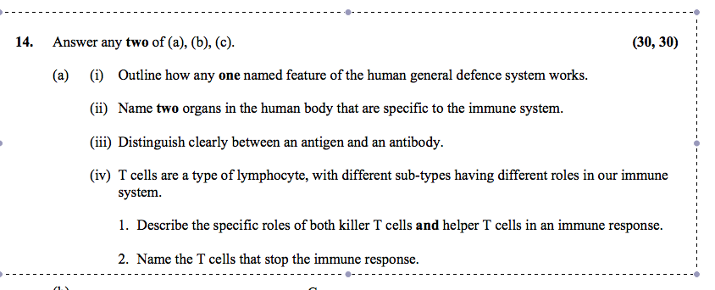
2013 HL 12 ©

2015 HL 14 (a)

2017 HL 14 (b)

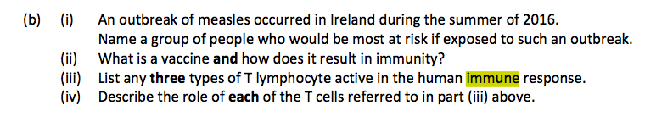

Marking Scheme
2005 HL
15. (a) (i) non-cellular / one nucleic acid / can reproduce in host cell only
or obligate parasite / do not possess organelles or named organelle any two 2(3)
(ii) Cold / ‘flu / polio / rabies / mumps / measles / AIDS (HIV)
any two 2(3)
(iii) B-cells/ T-cells or two named T cells e.g. helper / killer / suppressor / memory
any two 2(3)
B-cells – produce antibodies/agglutination or lysis / memory
T-cells – recognise / destroy infected or damaged cells / memory / activation /
suppress immune system
Helper T – stimulate B cells or stimulate killer T cells/ recognise antigens /
Killer T – Destroy infected or damaged cells /
Suppressor T – Switch off immune system or explained /
Memory T – memorise antigen
any two 2(3)
(iv) yes 3
in both cases the result is the production of antibodies 3

2006 HL
13. (c) (i) (lymph) nodes / (lymph) vessels 2(3)
(ii) transport / defence / fluid collection / (transport) of fats /
/ (transport) of hormones / (transport) of excretory matter / nodes filter /
bacteria or pathogens / produce lymphocytes or antibodies /
returns fluid to blood / absorbs fat / at lacteals / any six 6(3)

2007 HL
14. (c) (i) resistance to infection or to antigens [allow disease] 3
(ii) recognition / produce antibodies / specific to antigens or in response to
antigens [allow memory cells] 2(3)
(iii) active immunity: body produces antibodies 3
passive immunity: antibodies introduced to body 3
(iv) vaccination introduces antigen or explained / causes antibody production 2(3)
(v) 1. passive* 3
2. infection may already have occurred or possibility of dangerous
infection or example or no vaccine available or vaccine too expensive 3
3. short 3
2010 HL
6. (c)
(Older people) previous exposure / antibodies (or active immunity or memory
cells) 3 + 2

2012 HL 15 (b)

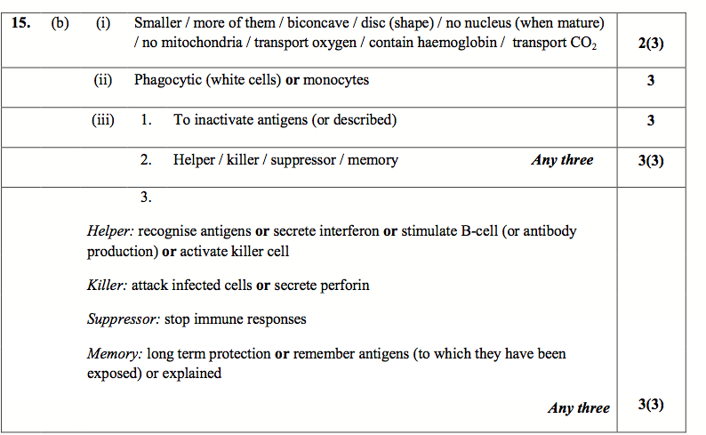

2015 HL 14 (a)
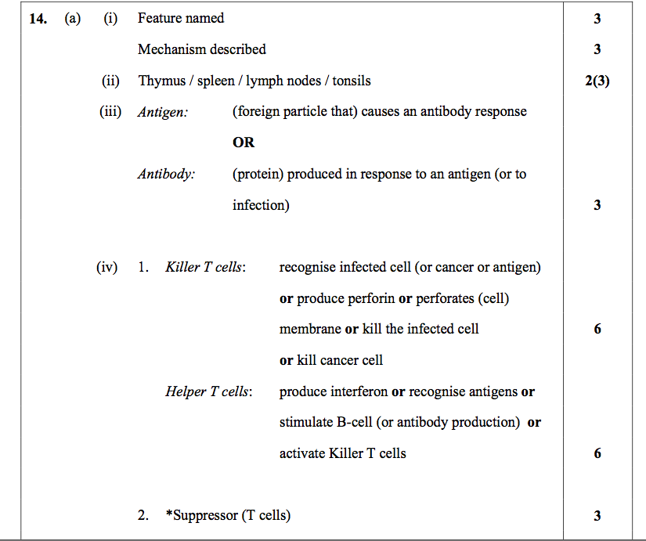

2017 HL 14 (b)

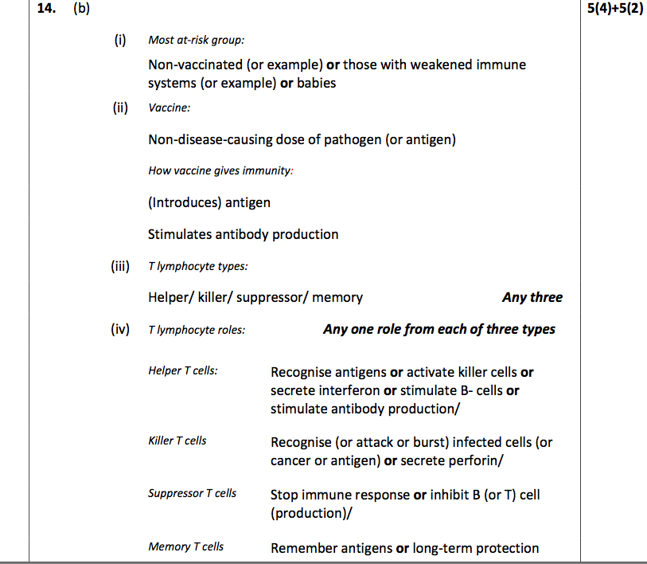

Immunity- (ability of body to resist infection)

Skin:
- barrier to m/o
- sebum (skin oil) and sweat are toxic to bacteria).
- symbiotic m/o on skin keep surface free of pathogenic m/o.
Cilia and mucus in respiratory tract continually remove dust and microbes by trapping and swallowing (coughing, sneezing & vomiting expel foreign bodies).
Stomach acid (HCl) kills m/o.
Lysozyme: an enzyme in saliva, tears and sweat kills most microbes by attacking their cell walls.
Urinogenital tract - acid nature of urine keeps tract free from bacteria
Blood clotting - prevents entry of m/o.
7. Phagocytes (WBC) - which engulf bacteria and digest them.
Induced immunity- using antibodies to resist specific diseases.
Artificial
Natural
Pathogens enter body in a natural manner. Lymphocytes (WBC) produces antibodies in response to antigens contained in the cell wall of an invading pathogen e.g. getting measles. This usually gives ‘life-time’ immunity because the memory cells, from first infection, will be able to produce loads of antibodies when exposed to same antigen again.

Body receives previously made antibodies in a natural manner i.e. antibodies transferred from mother to baby in womb and breast feeding - short-lived.
(6 months).

Passive
Antibodies from another organism enter person’s body

Active immunity
Antibodies produced in person’s body
The pathogen is introduced into the body as a vaccine. A vaccine is a non-disease causing pathogen (dead, treated or its toxin) that can stimulate the production of antibodies e.g. MMR.
.

Injection of ready-made antibodies into a person suffering the disease e.g. tetanus - short-lived.

Natural immunity- (resistance due to general body functions)

Natural
Artificial

