- Nutrition | Objectives  At the end of this sub section students should be able to:
1.3.1 Function of Food | - State the Function of Food  - Name three reasons for requiring food
1.3.2 Chemical Elements | - Name six common chemical elements in food: C, H, N, O, P, S  - Name five elements present in dissolved salts: Na, Mg, Cl, K, Ca  - Name 3 trace elements required: Fe, Cu, Zn
1.3.3 Biomolecular Structures | - Define Biomolecular Structures  - State that simple biomolecular units are composed of a combination of elements in different ratios e.g. carbohydrates C_{x}(H₂O)_{y}
1.3.4 Biomolecular Sources and the Components of Food | - Name the element components, biomolecular components and sources of: carbohydrates, fats & oil and proteins.  - State that carbohydrates are composed of indivisible units and give examples of these. Eg. Monosaccharide – glucose; Disaccharides – maltose; and Polysaccharides - starch/cellulose.  - Explain what a vitamin is.  - Name one water-soluble vitamin. Name one water in-soluble (fat-soluble) vitamin.  - List the sources of these vitamins
1.3.5 Energy Transfer Reactions | - Define of the terms: Anabolic and Catabolic.  - Give an example of each
1.3.6 Structural Role of Biomolecules | - State carbohydrates role as cellulose in cell walls  - State proteins role as fibrous protein e.g. keratin or as myosin  - State the role of lipids as Phospholipids in cell membranes
1.3.7 Metabolic Role of Biomolecules | - State that carbohydrates & lipids act as a primary source of energy.  - State that proteins act as enzymes and are made of amino acids  - State that hormones (protein) act as regulators of metabolic activity.  - State that vitamin C & D are used for tissue growth, cell production and health maintenance.  - Name disorders associated with deficiency of a water-soluble and a water in-soluble vitamin.
1.3.8 Minerals | - State the requirements & use of any 2 minerals in plants.  - State the requirements & use of any 2 minerals in animals.
- Water | - State five good reasons why water is important for organisms.
.

All living organisms require food:
- for energy (for heat & to drive chemical reactions & for continuity of life),
- to provide the necessary building materials for growth, maintenance & repair of cells.
- to control chemical reactions in cells

A balanced diet should contain 2/3 carbohydrates (including roughage), 1/6 protein, 1/6 fat, minerals, vitamins & water.
Energy value of food.
- 1 kcal = 4.2 kJ.
- 1 kJ is the amount of energy required to raise temp. of 1kg of water by 1ºC (calorimeter).
- 1g carbohydrate = 16kJ of energy / 1g protein = 17 kJ/ 1g fat = 38 kJ
1g alcohol = 29kJ!
- Daily food intake should contain enough kJ energy to keep all internal activities in the body going and also enough to carry out external work.
- The total amount of food intake depends on age (young people needing more than older individuals), level of activity, health and gender. Males need more food than females because they have a higher ratio of muscle to fat. More intake needed during pregnancy - growth of foetus- and lactation - milk production. Recommended allowance = 9600kJ for 16 year old girls and 12600 kJ for boys. Important to reduce fat intake when trying to control weight. Climate - more kJ required in colder weather/climates to maintain body temp.
There are four types of biomolecules (organic compounds) in food: proteins, carbohydrates, lipids and vitamins.
PROTEIN
(a) Elements:
C,H,O,N and/or S/P

(b) Structure:
Consists of repeating units of amino acids. There are about 20 different amino acids.
Amino acids link together in polypeptide chains to form proteins.
Basic unit = amino acid
H
⏐
R ⎯ C ⎯ NH₂
⏐
COOH
-NH₂ = amino group
-COOH = carboxylic acid group
-R = variable
Some polypeptide chains become
- twisted e.g. fibrous protein – keratin in hair, nails and feathers.
- folded e.g. globular proteins in enzymes and hormones
- folded and in addition have another chemical in the fold e.g. haemoglobin in red blood cells and glycoprotein on cell membranes.

Prions are proteins that do not fold correctly. They cause similar proteins to fold incorrectly. Cause BSE, nvCJD and scrapie.

Food sources:
Lean meat, egg white, fish, milk, soya, pulses, nuts & cheese.
Protein not stored in body – taken to liver and deaminated.

Role of proteins in cell structure and metabolism:
Cell structure:
Found in cell membranes, hair /nails(keratin), myosin in muscles, skin.
Metabolism:
The following are all made from protein - Enzymes (control chemical reactions), antibodies (fight infection), haemoglobin, prothrombin/ fibrinogen (for blood clotting), hormones (regulate body functions e.g. insulin controls glucose levels in blood) and chlorophyll (photosynthesis).

CARBOHYDRATES
Structure:
Carbohydrates consist of simple sugars.
General Formula: (CH₂O)_{n} (Ratio 1:2:1)
Elements: C:H:O

Types of carbohydrates | Reducing sugars | Soluble in water | Example
Monosaccharides  (1 sugar unit) | Yes | Yes | Glucose C₆H₁₂O₆(fruit e.g. grapes)  fructose (honey, sweet fruits)
Dissacharides  (2 sugar units) | All monosaccharides e.g. glucose, fructose and some dissacharides e.g. maltose, lactose (not sucrose!) | Yes | sucrose (table sugar) lactose (milk)  maltose (germinating seeds)
Polysaccharides  (many sugar units) | No | Insoluble | starch (bread, pasta, potatoes)  cellulose (veg., wholemeal bread) glycogen.

Role of carbohydrates in cell structure and metabolism
Cell structure:
- Cellulose – plant cell walls
- Chitin – fungi cell walls and exoskeleton of insects
Metabolism:
- Catabolic reactions e.g. respiration
C₆H₁₂O₆ + 6O₂ → 6CO₂ + 6 H₂O + Energy
- Anabolic reactions e.g.photosynthesis:
energy
6CO₂ + 6 H₂O → C₆H₁₂O₆ + 6O₂

Energy storage - stored in plants as starch & animals (muscles and liver) as glycogen

LIPIDS (fats and oils)
Elements:
C,H,O

Structure:
Basic unit = triglyceride
(1 glycerol & 3 fatty acids)

G
L
C
Y
E
R
O
L
__ FA

__ FA

__ FA

CH₂OH
⏐ Glycerol
CHOH
⏐
CH₂OH

Fatty acid:
HOOC - (CH₂)_{n} - R
- Saturated fat (single bonds only in fatty acids)- animal fat (hard e.g. butter)
- Unsaturated fat (double or triple bonds) - vegetable fat (soft, oils)
Structures:
Saturated fatty acids can be more easily converted into cholesterol. Too much cholesterol sticks to and thickens the lining of the blood vessels and may lead to heart attacks. ______FA
G
L
Y
C
E
R
O
L

Phospholipids
A phosphate replaces one of the fatty acids in a _______FA
lipid molecule.
_______Phosphate

Role of lipids in living organisms
Cell structure
- Phospholipids & lipoproteins are components of cell membranes.
- Heat insulation
- -stored in body as adipose tissue under skin (important in aquatic animals such as whales and seals. Why duck is a fatty meat!)
- Protect organs e.g. kidney, heart.
- Waterproofing e.g. oil on human skin (sebum) and birds’ feathers, the cuticles on leaves, seeds and fruits.
- Found as myelin on some nerves – increases speed at which messages are carried.

Metabolism
Reserve source of energy – have twice the energy value of carbos.
MINERALS
Essential inorganic elements required by the body in minute amounts to function properly.

Know two in detail re plants and animals e.g. Mg and Ca
Mineral | Source* | Use | Deficiency Disease
Ca | Dairy products e.g. cheese, milk; hard water; fish | Bones, teeth.  Calcium pectate in middle lamella -holds cell walls together. | Osteoporosis – weakening of bones
Mg | Wholegrain cereal, green vegs, cheese | Bones & teeth  Enzyme co-factor.  Nerve/muscle action.  Makes ATP  Makes chlorophyll in plants. | Weak bones  General weakness.  Poor growth
Fe | Liver, meat, spinach, nuts, egg yolk, legumes | Haemoglobin | Anaemia

*Source of plant minerals = soil water

VITAMINS are complex organic compounds needed in small amounts for normal health & growth. Many are co-enzymes (i.e. needed for enzymes to work).
Vitamin A,D,E,K are fat-soluble. Vitamin B & C are water- soluble.
Made in plants, bacteria and fungi, but not animals (except vitamin D - synthesised through skin on exposure to sunlight).
Deficiency diseases are caused by the lack of or reduced intake of one or more vitamins resulting from: inadequate diet, pregnancy & lactation, infection of the gastrointestinal tract, antibiotics, antivitamins e.g. raw fish binds vit. B₁

Learn one water-soluble and one fat-soluble vitamin in detail e.g. C and D
Vitamin | Food Source | Use | Deficiency disease/symptoms
C Ascorbic acid | blackcurrants, oranges, kiwi, limes and green veg, e.g. broccoli | 1. Making collagen for connective tissue – bone, skin, gums, cartilage, ligaments and lining of blood vessels.  2. Iron absorption. | Scurvy - bleeding of mouth and gums, loose teeth and slow healing of wounds.
D Calciferol | Dairy products, fish liver oils, sunshine on skin, egg yolk | Allows body absorb calcium – Ca needed in bone formation | Rickets (child – bones do not form properly (bow-legs, knock-knees)).  Osteomalacia (adults – bones lose calcium and become weak – painful and liable to fracture easily)

Chemical Tests

 | Reagent | Colour change | Heat
Protein e.g. egg white, milk | Biuret (NaOH & CuSO₄) | blue to violet | No
Starch (carbohydrate) | Iodine | reddish-brown to blue-black | No
Reducing sugar (carbohydrate) e.g. glucose | Benedict’s | blue to brick-red* | Yes
Lipids | Brown Paper | Translucent stain | No

* green, yellow and red indicate increasing quantities of reducing sugar.
Control (for comparison) = water.

WATER
Approx. 70% of body weight. (90%body mass in plants). Blood plasma is approx. 90% water.
Test for water:
- Dry CoCl₂ paper: blue to pink
- Dry CuSO₄: white to blue

Properties of water and why it is important to living organisms
(learn at least 3)
- Good solvent – allows transport and cell reactions.
Most substances dissolve in it, thus allowing
- transport of dissolved substances in animals (blood, lymph, tissue fluid) and plants (xylem/phloem).
[Osmosis – water helps in the movement of substances into and out of cells e.g. in lungs and digestive system.]
- cell reactions - as a medium to bring chemicals into contact and it takes part in some reactions e.g.
- hydrolysis – water is used to hydrolyse (split) many substances e.g. proteins into amino acids; fats to fatty acids and glycerol; and polysaccharides to monosaccharides.
- condensation reactions where smaller molecules join to form one larger molecule, with the elimination of water (e.g. glu + glu - water → maltose) and
- photosynthesis (water is broken down to supply hydrogens), respiration – water is a product
- Medium for dispersal e.g. gametes, pollen, spores, fruits and seeds.

- Good absorber of energy - provides stable temperatures.
A large increase in heat results in a small rise in temp. It tends to hold its temperature irrespective of fluctuations in the environmental temp. - suits enzymes because they have a limited temp. range for activity. Also, aquatic environments show less seasonal and diurnal temp. changes than on land, so growth of aquatic plants is more constant.

Lubricant

Mucus – used in intestines
- Synovial fluid – lubricates joints
- Pleural fluid – friction-free movement of lungs against ribs
- Pericardial fluid - friction-free movement of heart against ribs

- Support
Water is not easily compressed, making it useful in supporting organisms.
- Skeleton e.g. earthworms supported by the pressure of water within.
- Water has a high density and so supports the weight of aquatic plants and animals e.g. whales
- Maintains turgidity in plant cells - water present in vacuoles.
- Eye - shape of eye is due to watery humour in it.
- Foetus – Amniotic fluid supports and protects foetus.

- Large latent heat of vaporisation - Temperature control
It absorbs a lot of heat to evaporate and so sweating cools animals and transpiration cools plants.

- High surface tension - resulting from the inward cohesive forces of attraction between molecules causing the surface to have the smallest possible area - organism can walk or float on “skin”.

- Ice floats on freezing water (because water volume increases and therefore density decreases when it freezes - insulates aquatic organisms below from extreme cold.

- Neutral pH (7) - suitable for most enzymes.

- High cohesion (water molecules cling to each other) and lower adhesion (water molecules cling to other surfaces) contribute to capillarity in plants (water rising up the stems - against gravity) and soil (causes water to spread out in soil).

- Colourless - allows submerged plants to photosynthesise.

- Hearing and balance in ear – watery liquid in cochlea and semi-circular canals.

Vitamin | Food Source | Use | Deficiency disease/symptoms
C Ascorbic acid | blackcurrants, oranges, kiwi, limes and green veg, e.g. broccoli | 1. Making collagen for connective tissue – bone, skin, gums, cartilage, ligaments and lining of blood vessels.  2. Iron absorption. | Scurvy - bleeding of mouth and gums, loose teeth and slow healing of wounds.
D Calciferol | Dairy products, fish liver oils, sunshine on skin, egg yolk | Allows body absorb calcium – Ca needed in bone formation | Rickets (child – bones do not form properly (bow-legs, knock-knees)).  Osteomalacia (adults – bones lose calcium and become weak – painful and liable to fracture easily)

LC Questions Nutrition
- [2004 OL] [4]
Fats are composed of fatty acids and .......................................................................
What name is given to fats that are liquid at room temperature?............................................
State two functions of fats in the human body
(i) ............................................................................................................... (ii) ................................................................................................................
An example of a fat-soluble vitamin is
A good source of this vitamin is
A lack of this vitamin may lead to

- [2004 OL] [10]

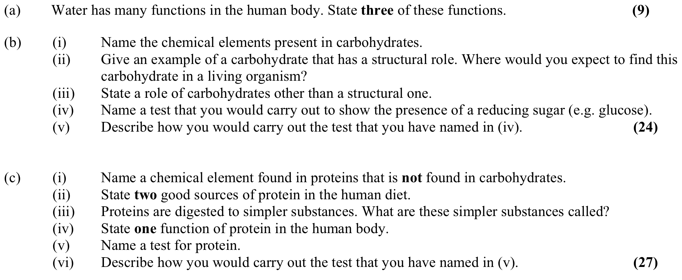
- [2005 OL] [5]
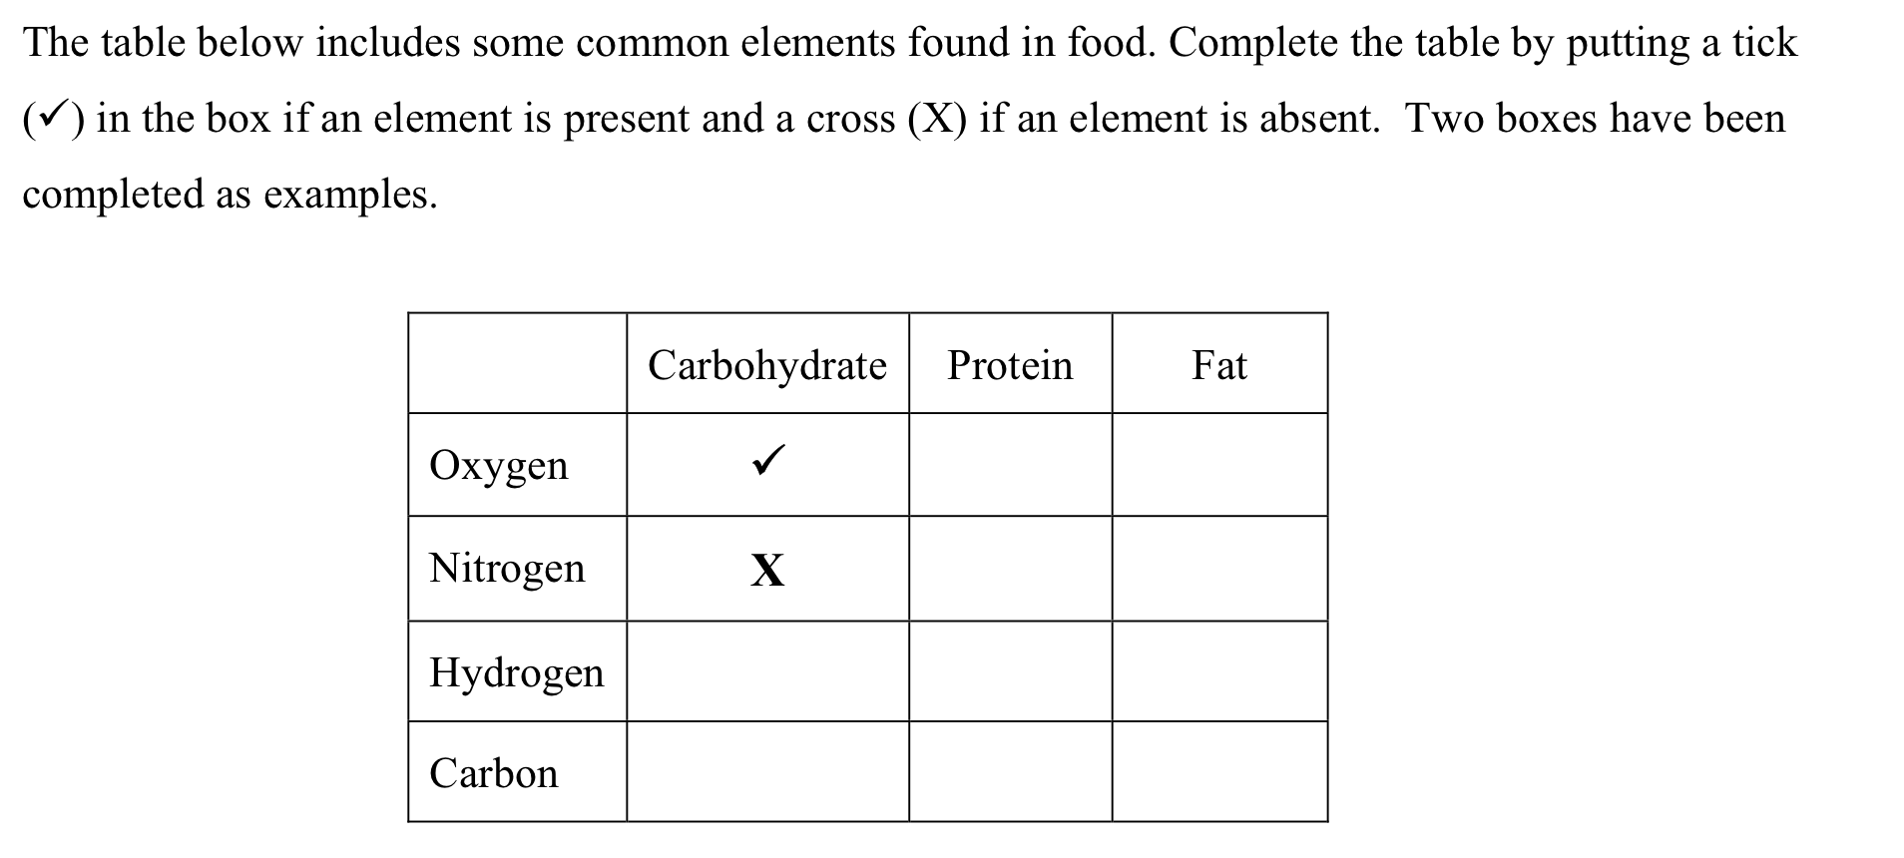

- [2006 OL] [3]
(a) Name the four elements that are always present in protein. .............................................
....................................................................................................................
(b) Name one other element that may be present in protein. ................................................
(c) Give two good sources of protein in the human diet. ....................................................
(d) Name a test or the solution(s) that is (are) used to detect protein in a food source. ...............
....................................................................................................................
(e) State the following in relation to (d).
  - The initial colour of the solution(s) .............................................................
  - The final colour if protein is present ..............................................................

- [2007 OL] [1]
Complete any four of the following.
(a) A carbohydrate is composed of carbon, hydrogen and ....................................................
(b) An example of a water-soluble vitamin is .................................................................
(c) A chemical that is used to show the presence of starch is ...............................................
(d) The liquid in which chemical reactions take place in the cell is ........................................
(e) Fats are made from fatty acids and ...........................................................................

- [2007 OL] [8]
(a)
(i) State one reason that your body needs protein...................................................... ............................................................................................................
(ii) Name the element, other than carbon, hydrogen and oxygen, which is always found in protein.
............................................................................................................ (b) Answer the following questions in relation to tests that you carried out for protein.
(i) Name two foods in which you found protein.
1. ...........................................................................................................
2. ...........................................................................................................
(ii) What reagent or chemicals did you use to test for protein? ............................................................................................................ ............................................................................................................
(iii) Was heat necessary in the test that you carried out?...............................................
(iv) What was the initial colour of the reagent or chemicals? ........................................
(v) What colour change occurred if protein was present?............................................. ............................................................................................................ ............................................................................................................ ............................................................................................................
(vi) Was there a colour change in the control? .......................................................

- [2008 OL] [2]
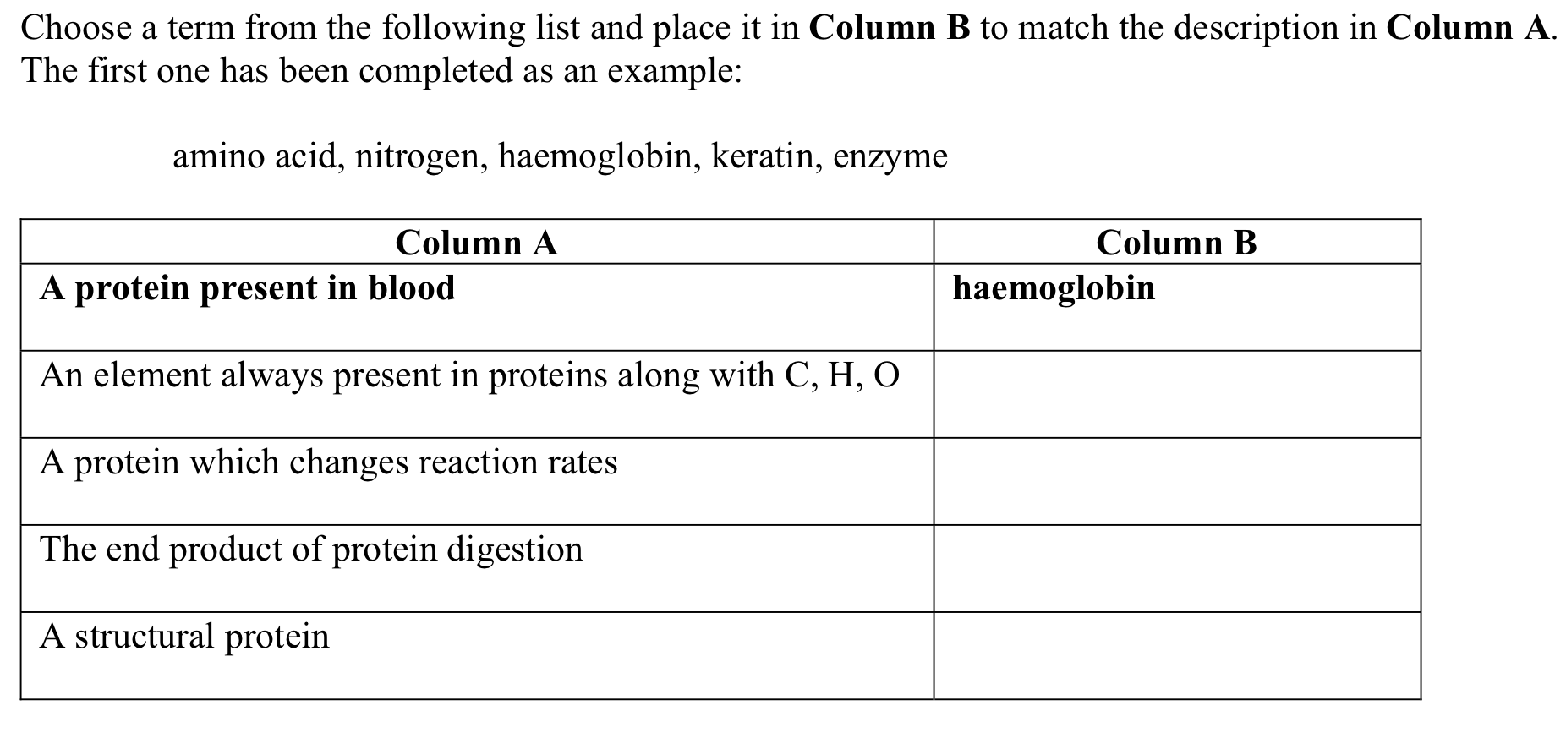
- [2009 OL] [1]
(a) Name the chemical elements present in carbohydrates.
_____________________________________________________________________________
(b) Which two of these elements always occur in a 2:1 ratio in carbohydrates?
______________________________________________________________________________
(c) Name a structural carbohydrate.
_____________________________________________________________________________
(d) Give a function of carbohydrates other than a structural one.
_____________________________________________________________________________
(e) Name a chemical element always present in proteins but not in carbohydrates.
_____________________________________________________________________________

- [2009 OL] [7]
The main ingredient in a sports drink is water.
(i) Give one reason why the body needs water.
_______________________________________________________________________
(ii) Give one way in which water is lost from the body.
______________________________________________________________________
(b) The composition of a colourless sports drink is to be investigated. Use your knowledge of food testing to answer the following:
1. (i) Name the test or name the chemical used to test the sports drink for the presence of glucose (reducing sugar).
_______________________________________________________________________
(ii) If glucose is present in the drink, what colour change would you expect to see? In your
answer give the initial and final colour of the test solution.
_______________________________________________________________________
(iii) Is heat necessary for this test?
_______________________________________________________________________
2. (i) Name the test or give the chemicals used to test the sports drink for the presence of protein.
_______________________________________________________________________
(ii) If protein is present in the drink, what colour change would you expect to see? In your
answer give the initial and final colour of the test solution.
_______________________________________________________________________
(iii) Is heat necessary for this test?
_______________________________________________________________________

- [2010 OL] [2]
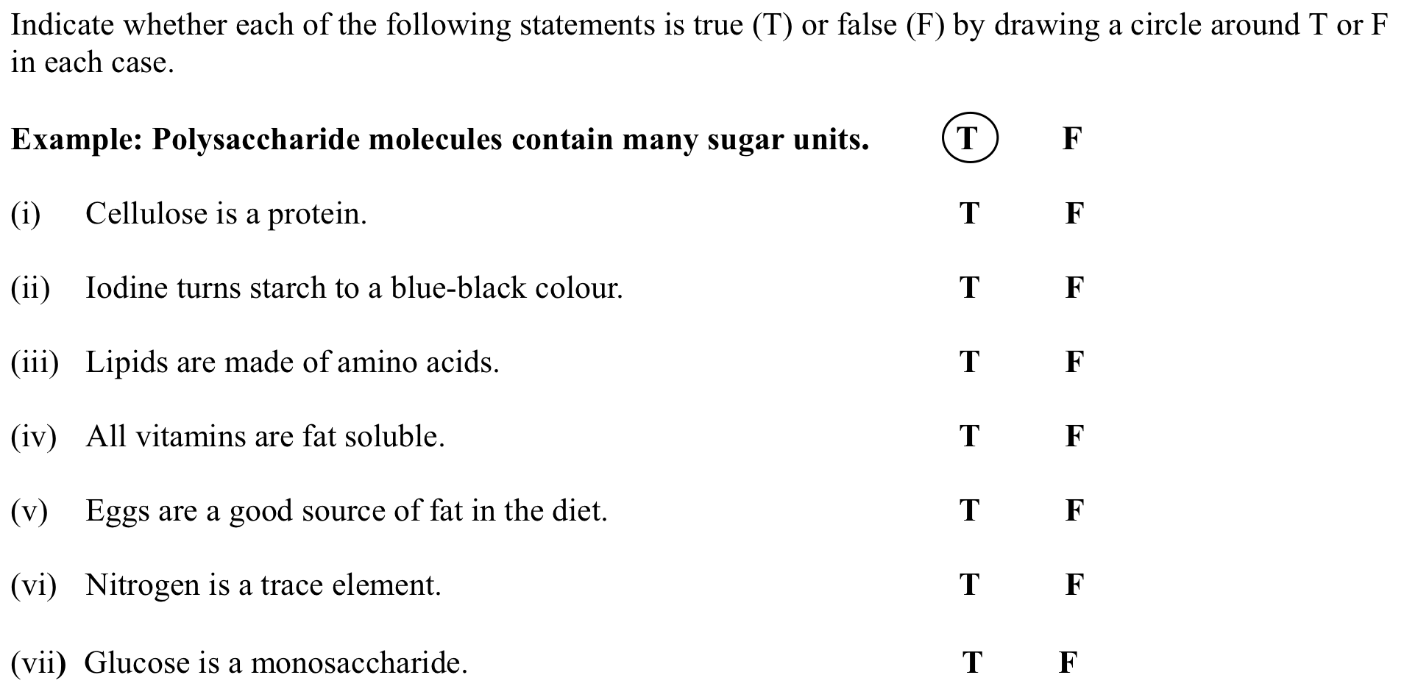
- [2011 OL] [1]
Use your knowledge of nutrition to answer the following questions:
(i) Carbohydrates always contain the elements carbon, hydrogen and _____________________________________________________________________________ (ii) Lipids are made up of fatty acids and ______________________________________________________________________________ (iii) Name a fat-soluble vitamin. _____________________________________________________________________________ (iv) Name a structural carbohydrate found in plants. _____________________________________________________________________________ (v) Name one good source of protein in the human diet. _____________________________________________________________________________

- [2012 OL] [1]
A student brings a tuna and sweetcorn sandwich, an apple and a bag of crisps for her lunch.
(a) What food in the student’s lunch is:
  - (i) a good source of protein?_______________________________________________________
  - (ii) a good source of fat? __________________________________________________________
(b) Vitamins form part of a healthy diet and prevent many disorders.
  - (i) Name one water-soluble vitamin. ________________________________________________
  - (ii) Suggest one food in the lunch that contains the water-soluble vitamin you have named.
__________________________________________________________________________________
(c) Name one structural protein in humans. __________________________________________________
(d) Give one function of fat in the human body. ______________________________________________

- [2012 OL] [9]
(a)
Give two reasons why water is important for all living organisms.
(i) __________________________________________________________________
(ii) __________________________________________________________________
(b) Answer the following questions in relation to food tests that you carried out as part of your practical work.
(i) What chemical did you use to test the food for starch? _______________________________
(ii) Was heat necessary for this test? _________________________________________________
(iii) How did you know that starch was present?
___________________________________________________________________________
(iv) What control did you use in this test?
___________________________________________________________________________ ___________________________________________________________________________
(v) Another food was tested for the presence of protein. What solution was used to test for protein?
___________________________________________________________________________
(vi) What was the initial colour of the protein-testing solution before you put it on the food?
___________________________________________________________________________
(vii) Was heat necessary for this test? _________________________________________________
(viii) What colour indicated that protein was present in the food?
___________________________________________________________________________

- [2013 OL] [1]
- Use your knowledge of nutrients to answer the following questions:
(a) Proteins always contain the elements carbon, hydrogen, oxygen and ..........................................................................................................................................................................
(b) Glucose is an example of which type of biomolecule? ..........................................................................................................................................................................
(c) An example of a fat-soluble vitamin is ..........................................................................................................................................................................
(d) A solution used to test for the presence of glucose is ..........................................................................................................................................................................
(e) Calcium and iron are examples of essential ..........................................................................................................................................................................

- [2005 HL] [1]
Answer five of the following by writing a word in the space provided.
(a) Cellulose is an example of a structural ...................................................................
(b) Vitamins are either water-soluble or ...............................................-soluble.
(c) Fats are composed of oxygen, hydrogen and ........................................................
(d) When an iodine solution is added to a food sample and remains red-brown in colour,
........................ is absent.
(e) When two monosaccharides unite they form a ...........................................................
(f) Removal from the body of the waste products of metabolism is called................................

- [2006 HL] [7(a)]
State a use of each of the following in the biology laboratory.
(i) Biuret test (copper sulphate and sodium hydroxide solutions).................................... .............................................................................................................
(ii) Benedict’s (or Fehling’s) test ......................................................................... .............................................................................................................

- [2007 HL] [1]
Give an example of five of the following;
(a) A catabolic reaction in an animal. ................................................................................
(b) An anabolic reaction in a plant. ...................................................................................
(c) A fat-soluble vitamin. ..............................................................................................
(d) A reducing sugar. ...................................................................................................
(e) A polysaccharide....................................................................................................
(f) A trace element in the human diet ...............................................................................

- [2008 HL] [1]
Answer five of the following by filling in the blank spaces.
(a) Biomolecules of the general formula Cx(H2O)y are examples of ............................................
(b) Give two functions of water in a living organism.
1. ......................................................................................................................
2. ......................................................................................................................
(c) Is energy release a feature of anabolic or catabolic reactions? ...............................................
(d) How do fats differ from oils at room temperature?................................................................
(e) Name the test or give the chemicals used to detect the presence of protein in a food sample
.............................................................................................................................
(f) Name a structural polysaccharide ..................................................................................

- [2009 HL] [1]
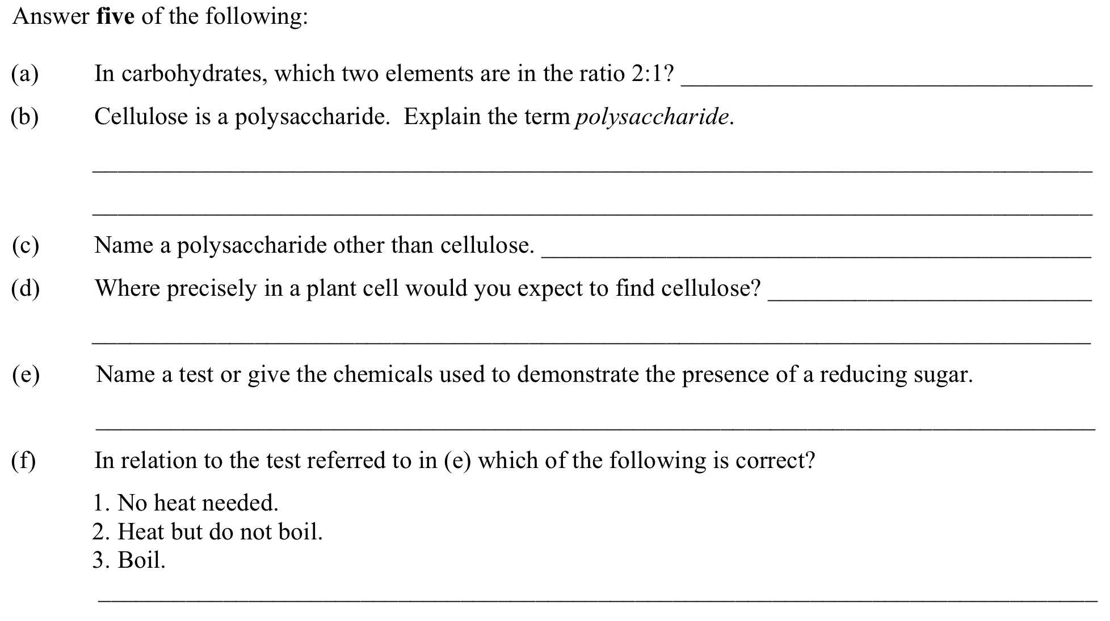

- [2010 HL] [1]
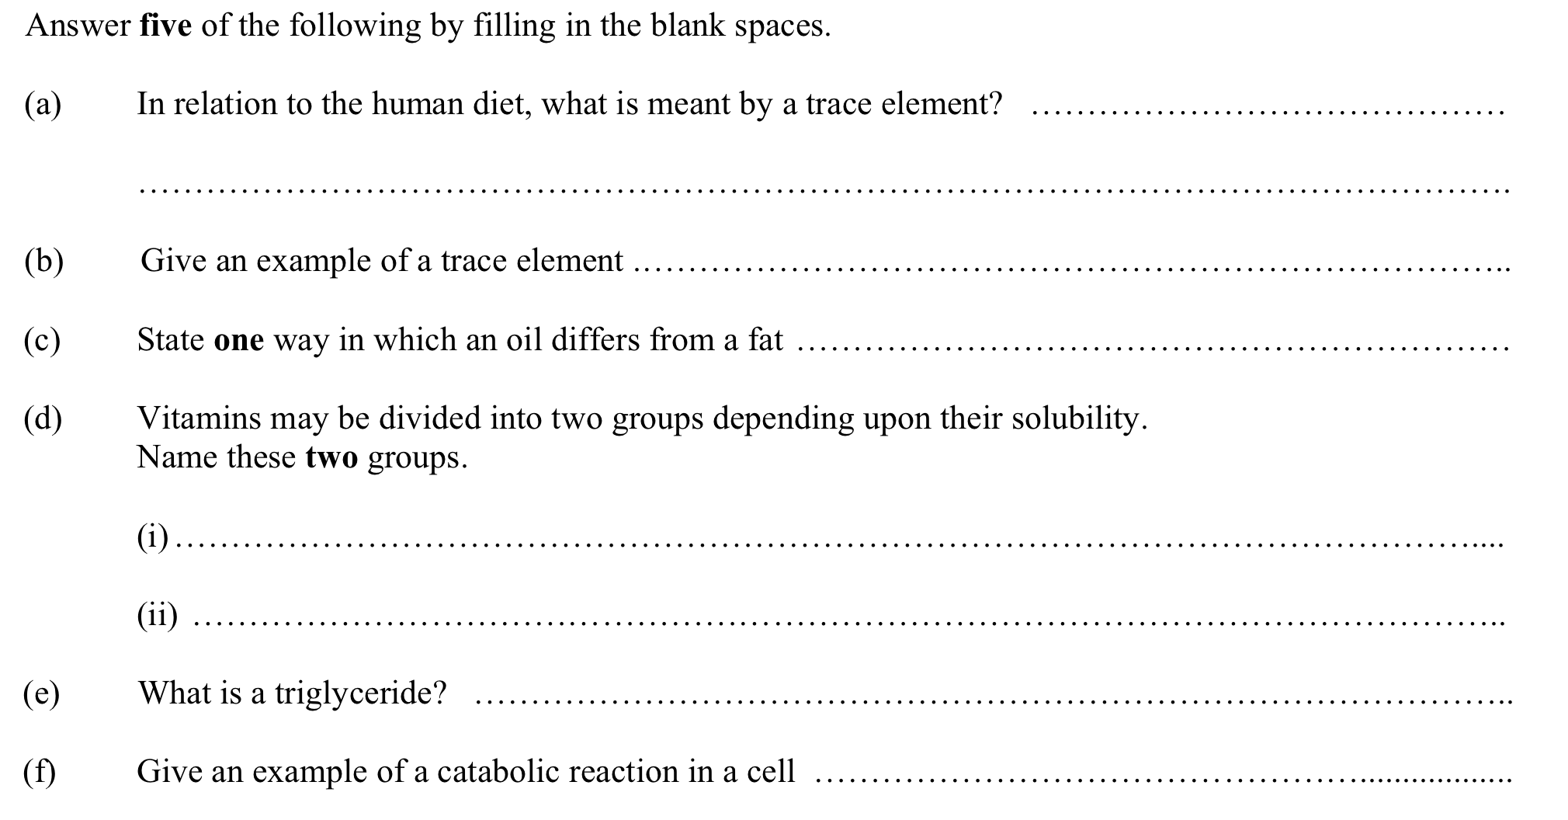
- [2010 HL] [8(b)(v)]
1. Biuret solution or alkaline copper sulphate in food testing………………………………
2. Brown paper or Sudan III in food testing. ...............................................................................................................

- [2011 HL] [1]
(a) Which food type may be identified in the laboratory by the use of Sudan III or brown paper? ________________________________________________________________________________
(b) Give one role for a named mineral in plants. ________________________________________________________________________________
(c) What colour indicates a strong positive result of the Fehling’s or Benedict’s test for reducing sugar? ________________________________________________________________________________
(d) Give a role of lipids in cells. ________________________________________________________________________________
(e) Give a role of water in the human body other than as a component of cytoplasm and body fluids. ________________________________________________________________________________
(f) How many common amino acids are found in proteins? _____________________

- [2012 HL] [1]
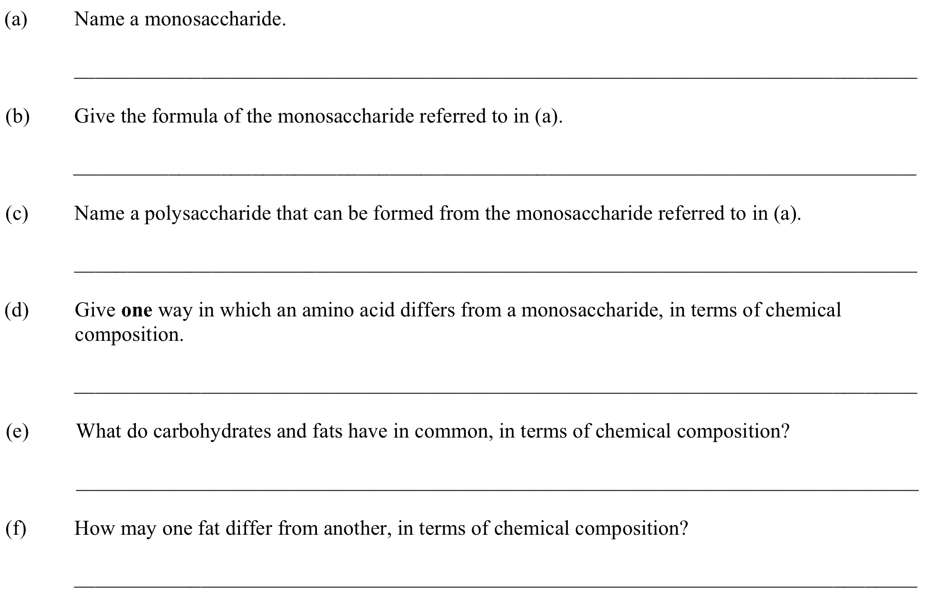
- [2013 HL] [1]
In the case of any five of the following pairs of terms, clearly distinguish between the first term and second term by writing a brief sentence about each.
(a) Starch. _______________________________________________________________________ Glucose. _______________________________________________________________________
(b) Amino acids. _____________________________________________________________________ Proteins. ____________
(c) Cellulose.
Keratin.
(d) Enzymes.
Hormones.
(e) Biuret test.
Benedict’s (Fehling’s) test. __________________________________________________________
(f) Fats. ___________________________________________________________________________ Oils. ___________________________________________________________________________

Marking schemes Nutrition
1. [2004 OL] [4]
- 2004 OL] [10]
- [2005 OL] [5]
- [2006 OL] [3]
- [2007 OL] [1]
- [2007 OL] [8]
- [2008 OL] [2]
- [2009 OL] [1]
- [2009 OL] [7]
- [2010 OL] [2]
- [2011 OL] [1]
- [2012 OL] [1]
- [2012 OL] [9]
- [2013 OL] [1]
- [2013 OL] [2]
- [2005 HL] [1]
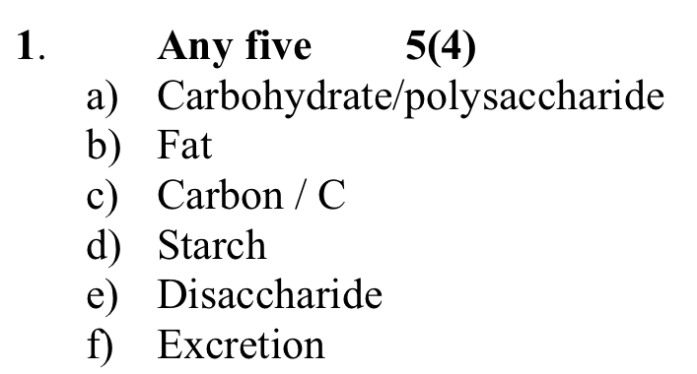
- [2006 HL] [7]
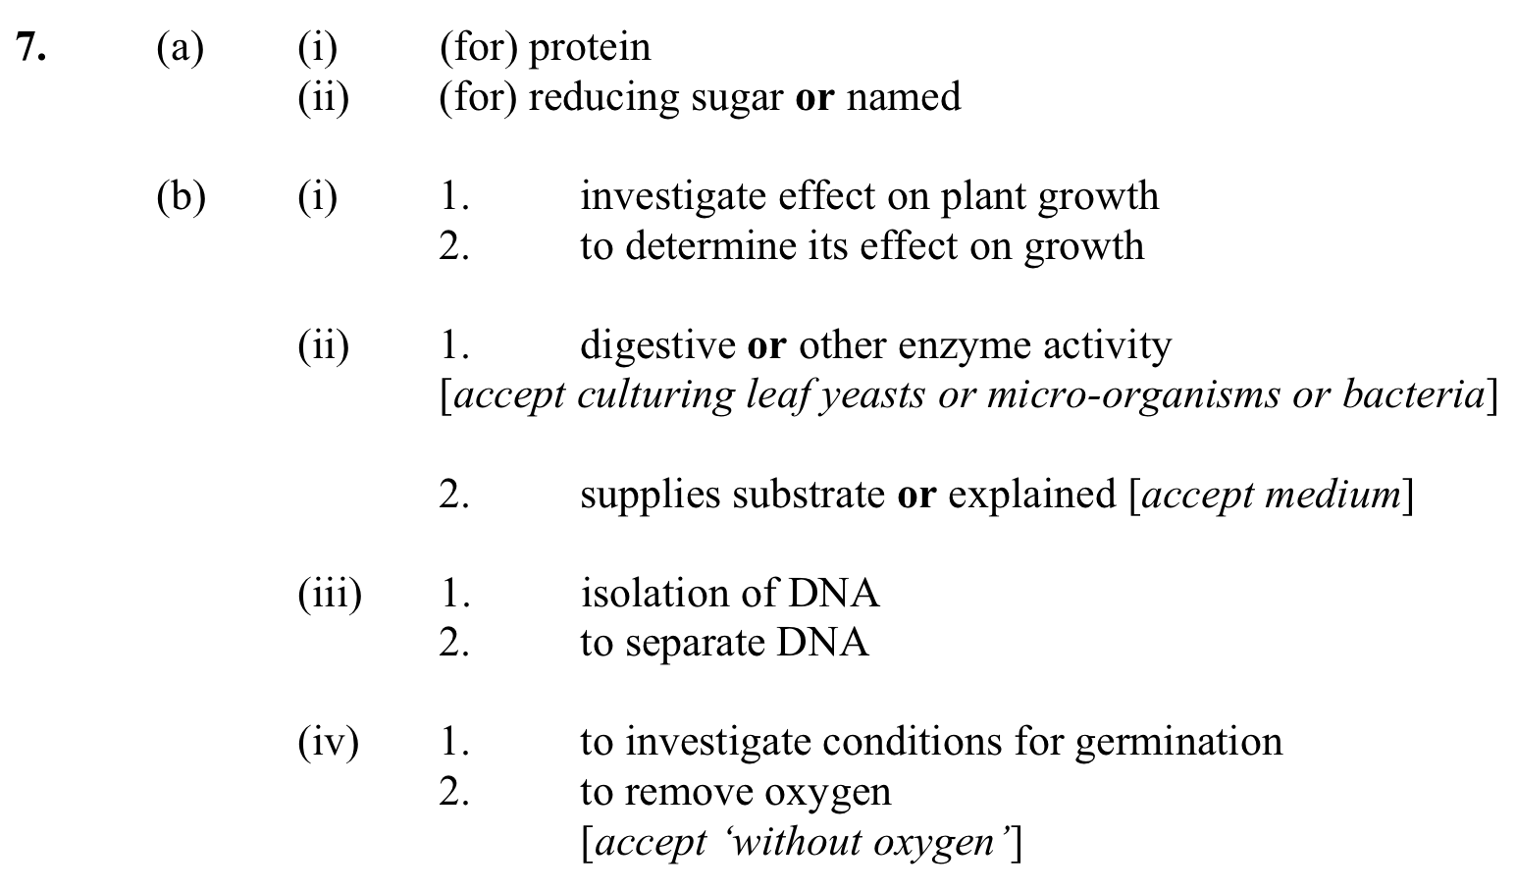
- [2007 HL] [1]
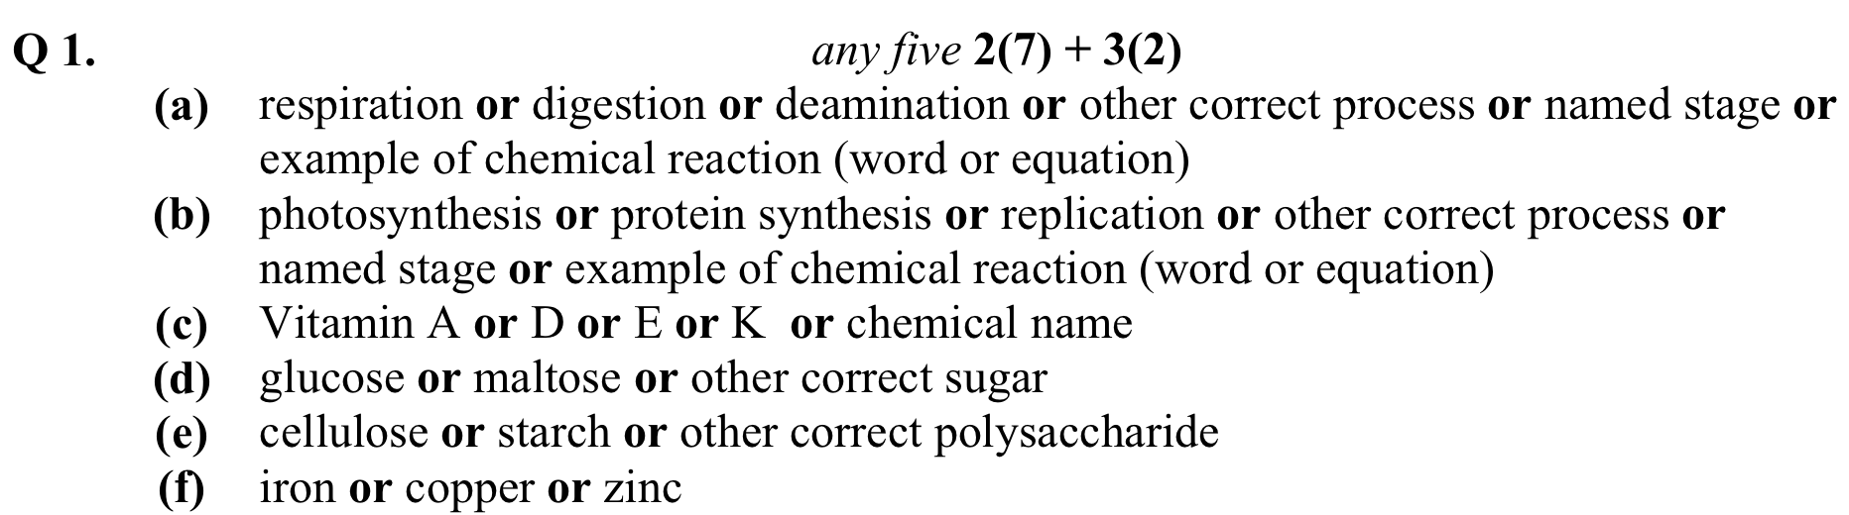
- [2008 HL] [1]
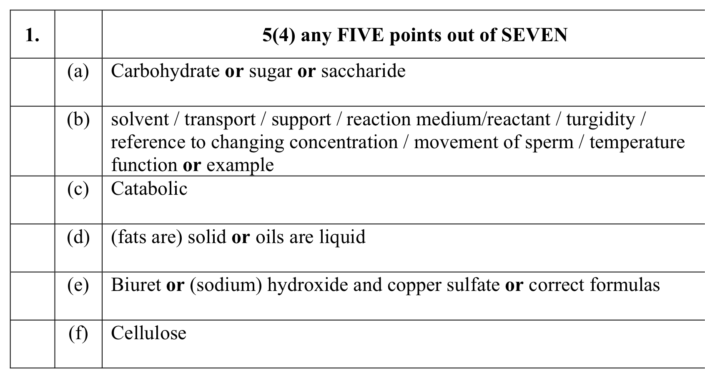
- [2009 HL] [1]
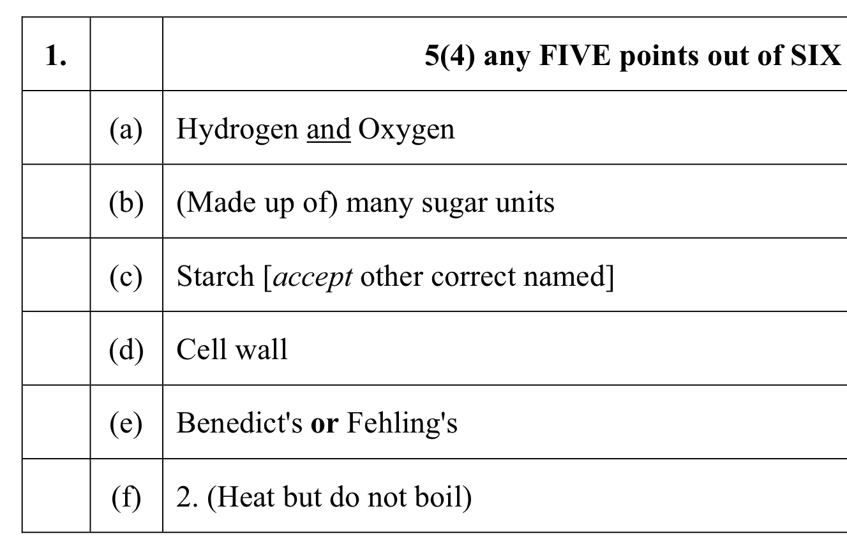
- [2010 HL] [1]
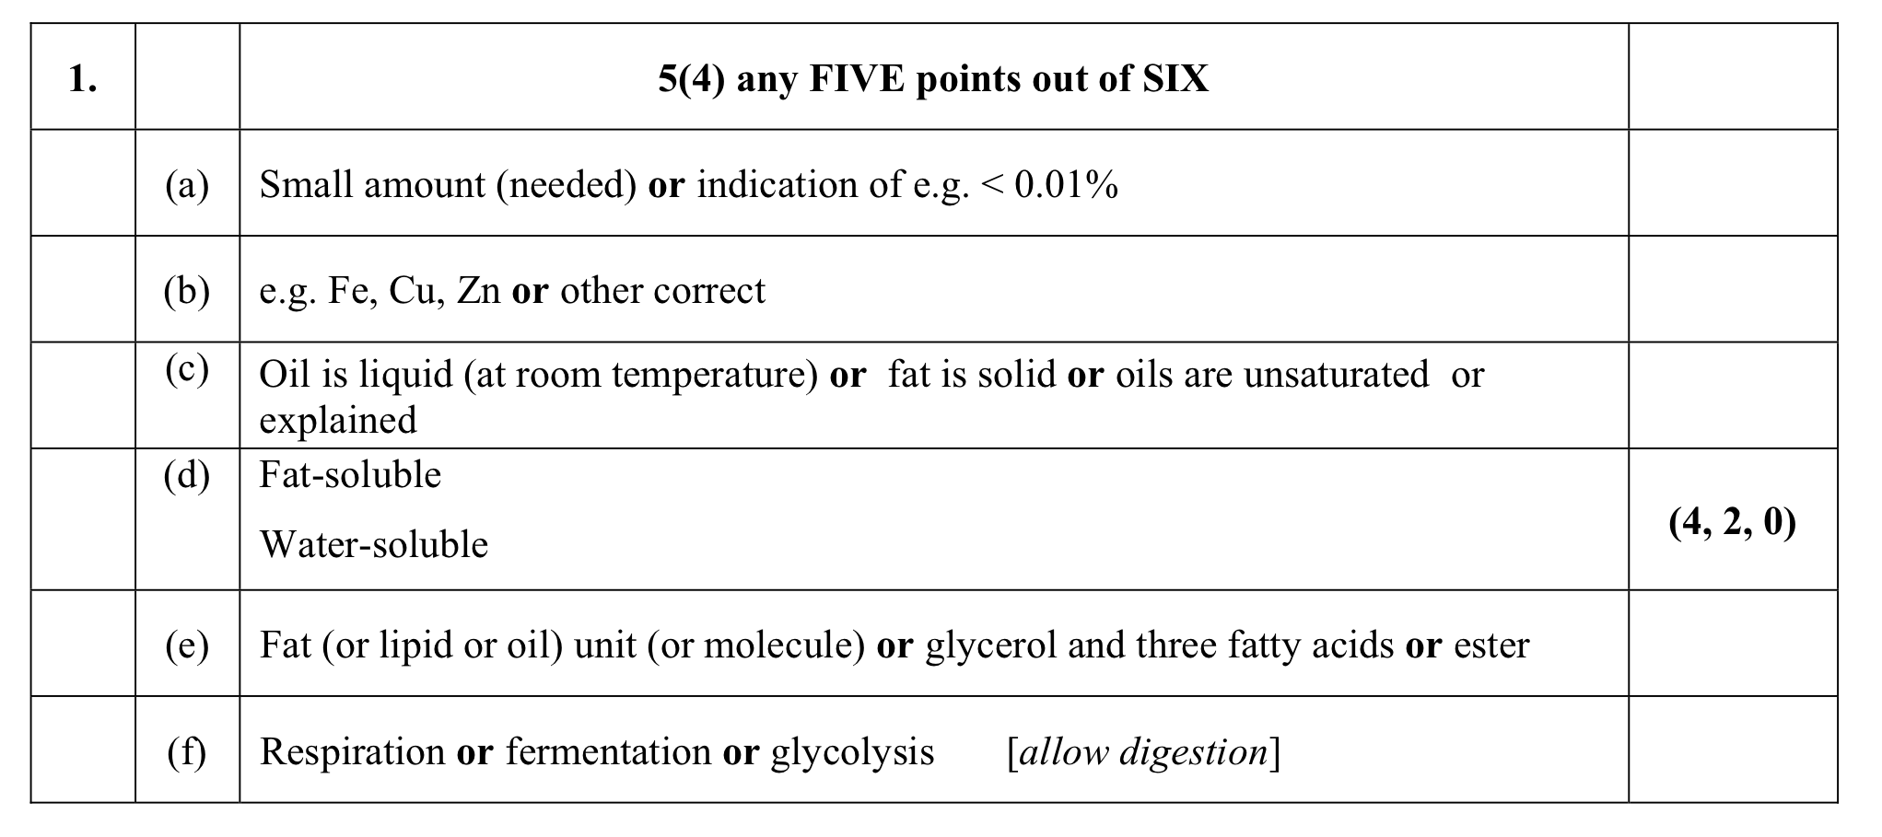
- [2010 HL] [8]
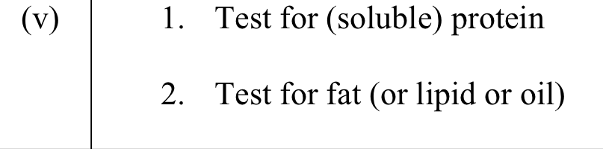
- [2011 HL] [1]
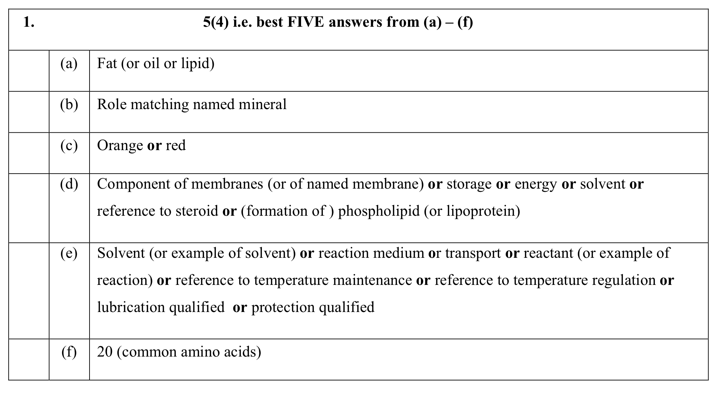
- [2012 HL] [1]
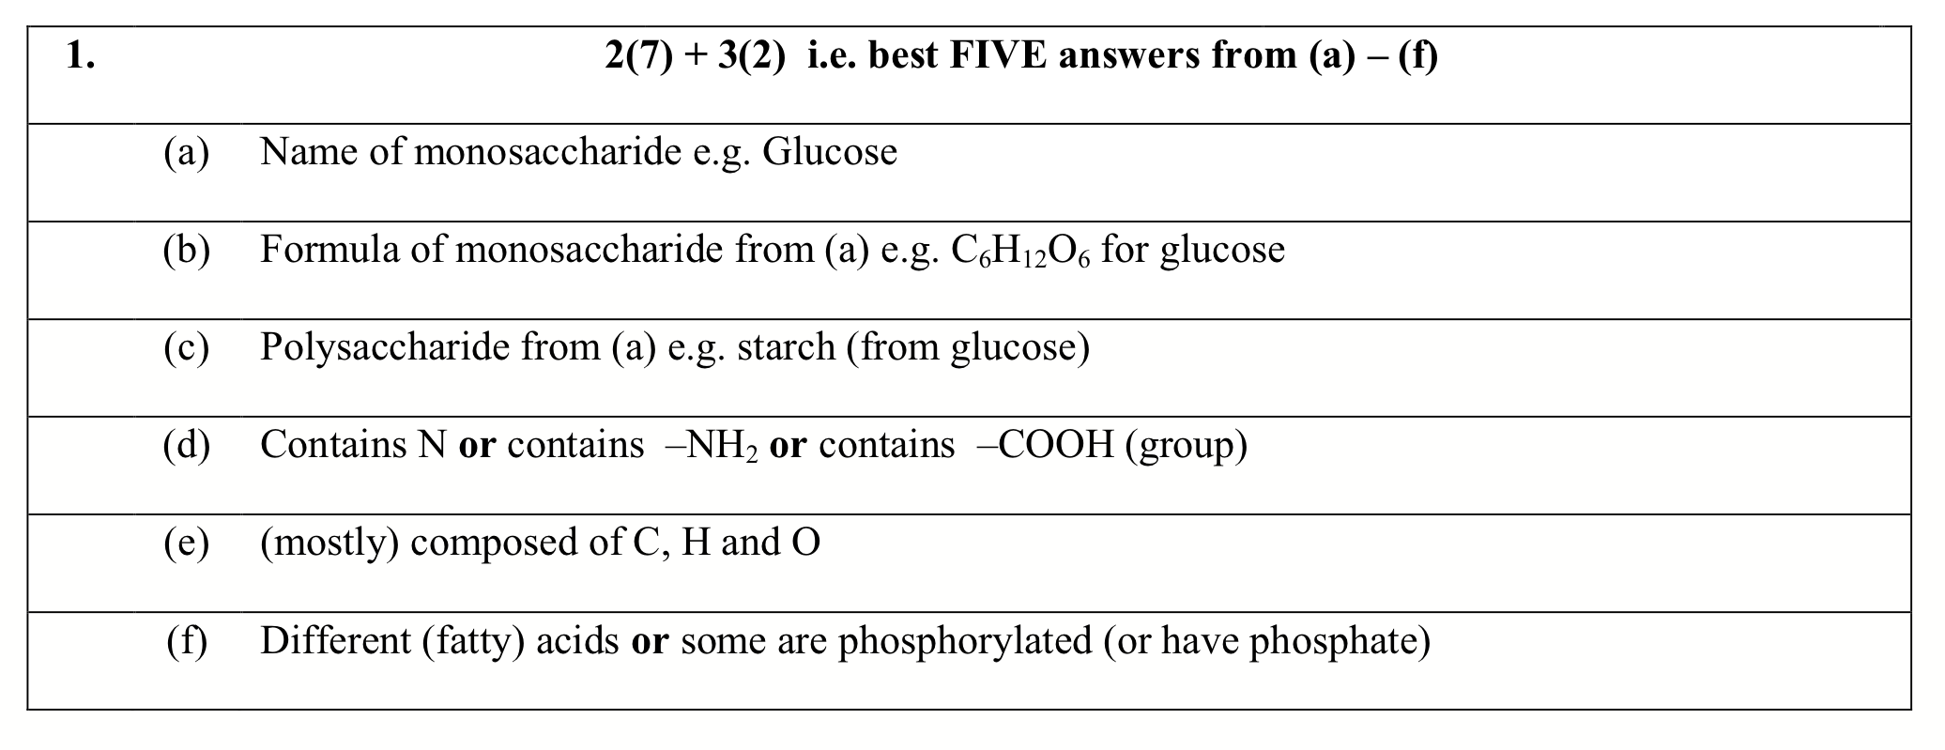
- [2013 HL] [1]
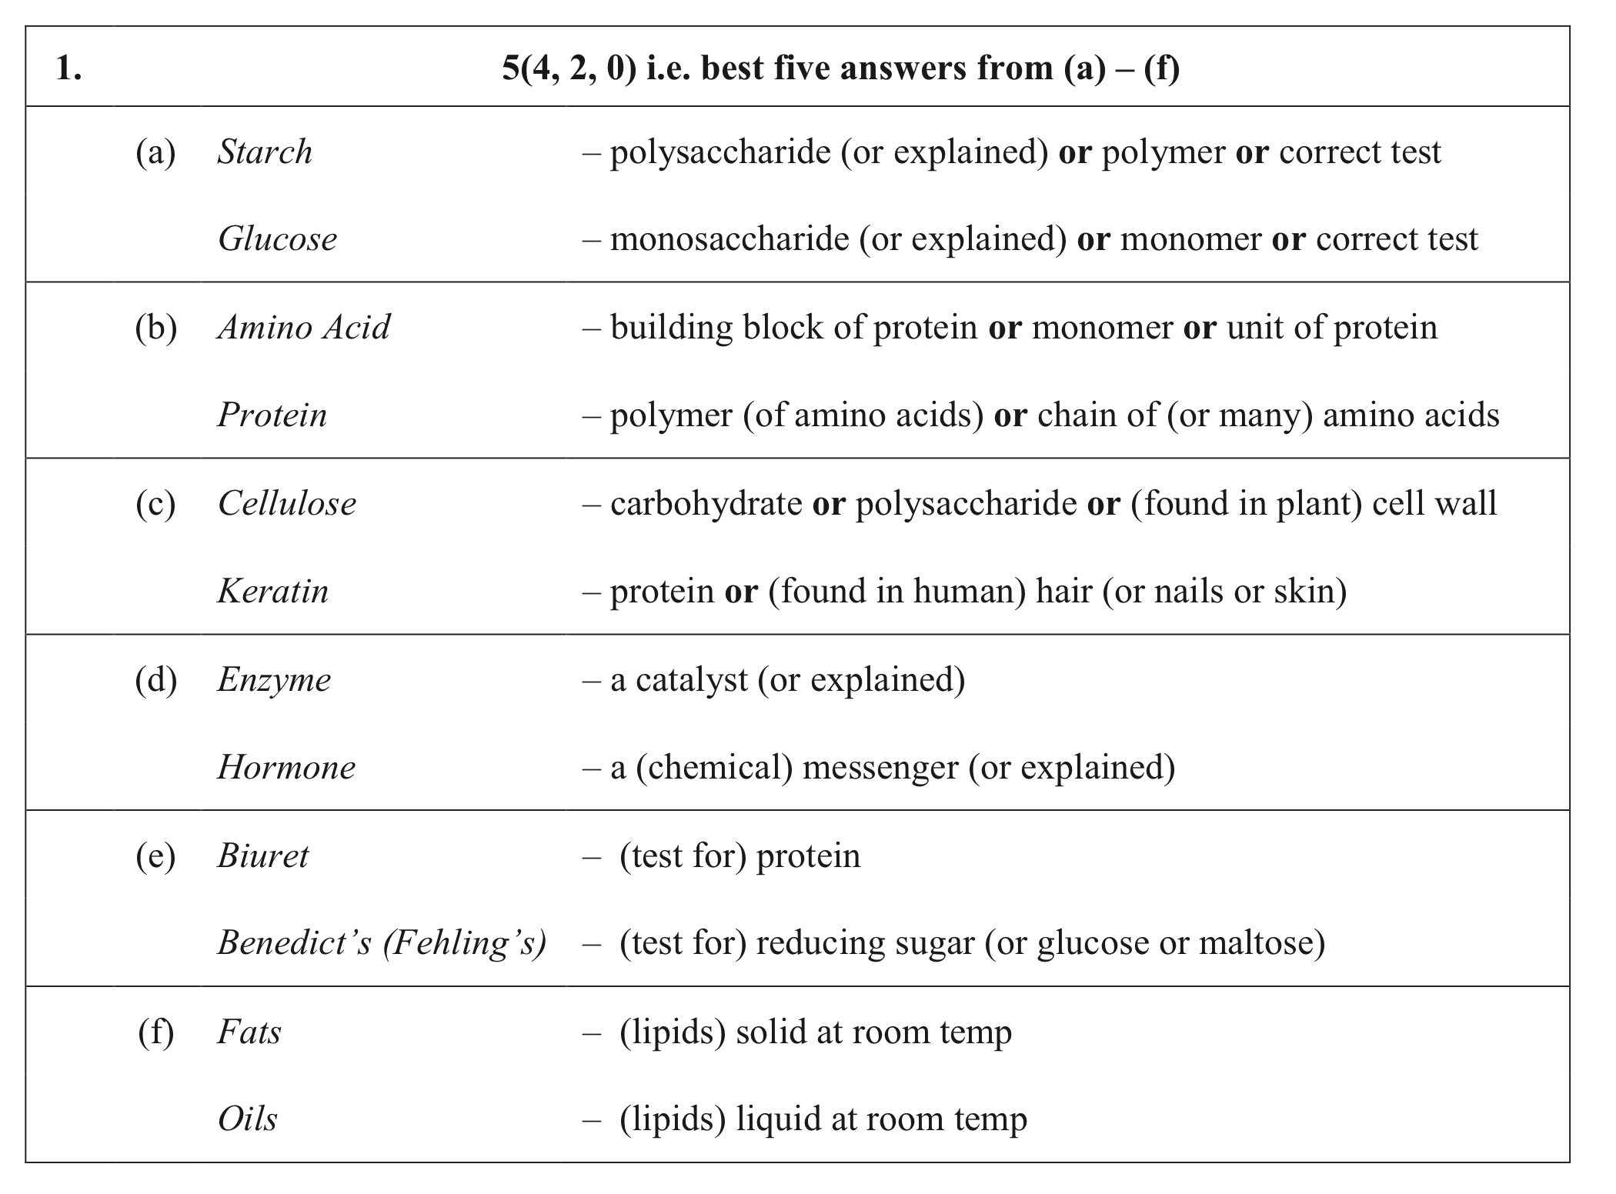

1.3.2 Chemical Elements
2010 OL

2. Indicate whether each of the following statements is true (T) or false (F) by drawing a circle around T or F in each case.
Example: Polysaccharide molecules contain many sugar units. F
(vi) Nitrogen is a trace element. T F
2006 HL
1. Answer five of the following by filling in the blank space.
(a) In the human diet zinc, iron and copper are examples of _________________________
2007 HL
1. Give an example of five of the following;
- A trace element in the human diet ……………………………………………………...
2010 HL
1. Answer five of the following by filling in the blank spaces.
(a) In relation to the human diet, what is meant by a trace element?
(b) Give an example of a trace element.

1.3.3 Biomolecular Structures
2004 OL
10. (b) (i) Name the chemical elements present in carbohydrates.

2007 OL
1. Complete any four of the following.
(a) A carbohydrate is composed of carbon, hydrogen and …………………………….........

2009 OL
1. (a) Name the chemical elements present in carbohydrates.
(b) Which two of these elements always occur in a 2:1 ratio in carbohydrates?

2010 OL
2. Indicate whether each of the following statements is true (T) or false (F) by drawing a circle around T or F in each case.
Example: Polysaccharide molecules contain many sugar units. F
(vii) Glucose is a monosaccharide. T F
2004 HL
- (d) What is the ratio of hydrogen atoms to oxygen atoms in a carbohydrate?
2008 HL
- (a) Biomolecules of the general formula Cx(H2O)y are examples of ……………………….
2009 HL
- (a) In carbohydrates, which two elements are in the ratio 2:1? _______________

1.3.4 Biomolecular Sources & Components of Food

S.E.C. Sample Paper OL
5. (a) Name a fat-soluble vitamin ……………………………………………………….
State a good source of this vitamin in the human diet ……………………………

2004 OL
5. Fats are composed of fatty acids and …………………..………………….…………….
What name is given to fats that are liquid at room temperature? ……………………….
An example of a fat-soluble vitamin is ………………………………………………….
A good source of this vitamin is ………………………………………………………...

2004 OL
10. (b) (iv) Name a test that you would carry out to show the presence of a reducing sugar (e.g.
glucose).
(v) Describe how you would carry out the test that you have named in (iv).

(c) (i) Name a chemical element found in proteins that is not found in carbohydrates.
(ii) State two good sources of protein in the human diet.
(iii) Proteins are digested to simpler substances. What are these simpler substances called?
(v) Name a test for protein.
(vi) Describe how you would carry out the test that you have named in (v). (27)
2005 OL
5. The table below includes some common elements found in food. Complete the table by putting a tick (✓) in the box if an element is present and a cross (X) if an element is absent. Two boxes have been completed as examples.

 | Carbohydrate | Protein | Fat
Oxygen | ✓
Nitrogen | X
Hydrogen
Carbon

2006 OL
3. (a) Name the four elements that are always present in protein. …………………………….
Name one other element that may be present in protein. ………………………………….
- Give two good sources of protein in the human diet ………………………………………
- Name a test or the solution(s) that is (are) used to detect protein in a food source …………
- State the following in relation to (d).
  - The initial colour of the solution(s) ………………………………………………….
  - The final colour if protein is present ………………………………………………...

2007 OL
1. Complete any four of the following.
( (b) An example of a water-soluble vitamin is
(c) A chemical that is used to show the presence of starch is
( (e) Fats are made from fatty acids and
2007 OL
8. (a)(ii)Name the element, other than carbon, hydrogen and oxygen, which is always found in protein.
b) Answer the following questions in relation to tests that you carried out for protein.
(i) Name two foods in which you found protein.
(ii) What reagent or chemicals did you use to test for protein?
(iii) Was heat necessary in the test that you carried out?
(iv) What was the initial colour of the reagent or chemicals?
(v) What colour change occurred if protein was present?……………………………………...
(vi) Was there a colour change in the control? ..
2008 OL
2. Choose a term from the following list and place it in Column B to match the description in Column A.
The first one has been completed as an example:
amino acid, nitrogen, haemoglobin, keratin, enzyme
Column A | Column B
A protein present in blood | haemoglobin
An element always present in proteins along with C, H, O
The end product of protein digestion

2009 OL
1. (e) Name a chemical element always present in proteins but not in carbohydrates.
______________________________________________________________________

2009 OL
7. (b) The composition of a colourless sports drink is to be investigated. Use your knowledge
of food testing to answer the following:
1. (i) Name the test or name the chemical used to test the sports drink for the presence
of glucose (reducing sugar).
__________________________________________________________________
(ii) If glucose is present in the drink, what colour change would you expect to see? In your answer give the initial and final colour of the test solution.
__________________________________________________________________
(iii) Is heat necessary for this test?
__________________________________________________________________
2. (i) Name the test or give the chemicals used to test the sports drink for the presence
of protein.
__________________________________________________________________
(ii) If protein is present in the drink, what colour change would you expect to see? In
your answer give the initial and final colour of the test solution.
__________________________________________________________________
(iii) Is heat necessary for this test?
__________________________________________________________________
2009 OL
15. (c) (i) To what group of biomolecules do enzymes belong?
(ii) Name the small molecules which are the building blocks for these biomolecules.
2010 OL
2. Indicate whether each of the following statements is true (T) or false (F) by drawing a circle around T or F in each case.
Example: Polysaccharide molecules contain many sugar units. F
(iii) Lipids are made of amino acids. T F
(iv) All vitamins are fat soluble. T F
(v) Eggs are a good source of fat in the diet. T F

S.E.C. Sample Paper HL

10. (a) (i) The same elements are found in carbohydrates and fats. Name these elements.
(ii) State one way in which carbohydrates differ from fats.
(iii) How do phospholipids differ from other lipids? (9)
- Carbohydrates are classified as monosaccharides, disaccharides and polysaccharides.
- Name a monosaccharide
- What is a disaccharide?
- Cellulose is a polysaccharide. What is it formed from?
- Name a polysaccharide that has a different role to cellulose.
- Describe a test for a named polysaccharide.
- Answer the following in relation to a test for
1. a reducing sugar 2. a protein
  - Name the reagent(s) used.
  - State the initial colour of the reagent.
  - State whether the test requires heat.
  - What colour indicates a positive result?
2005 HL
1. (b) Vitamins are either water-soluble or ……………..-soluble.
- Fats are composed of oxygen, hydrogen and ………………………………...…………
- When an iodine solution is added to a food sample and remains red-brown in colour, ……………………… is absent.
- When two monosaccharides unite they form a …………………………………………

2006 HL
1. Answer five of the following by filling in the blank space.
- Vitamin ……………….. is an example of a water-soluble vitamin.

2006 HL
7. (a) State a use of each of the following in the biology laboratory.
(i) Biuret test (copper sulphate and sodium hydroxide solutions) …………………………..
(ii) Benedict’s (or Fehling’s) test

2007 HL
1. Give an example of five of the following;
(c) A fat-soluble vitamin …………………………………………………………………….
(d) A reducing sugar. ………………………………………………………………………...
(e) A polysaccharide ………………………………………………………………………...
2008 HL
1.
(e) Name the test or give the chemicals used to detect the presence of protein in a food sample

2009 HL
1. (b) Cellulose is a polysaccharide. Explain the term polysaccharide.
(c) Name a polysaccharide other than cellulose. ______________________________________
(e) Name a test or give the chemicals used to demonstrate the presence of a reducing sugar.
(f) In relation to the test referred to in (e) which of the following is correct?
- No heat needed.
- Heat but do not boil.
- Boil.
2010 HL
1. (c) State one way in which an oil differs from a fat
(d) Vitamins may be divided into two groups depending upon their solubility.
Name these two groups.
(e) What is a triglyceride?
2010 HL
8. (b) For which purpose did you use each of the following in the course of your practical studies?
(v) 1. Biuret solution or alkaline copper sulphate in food testing.
2. Brown paper or Sudan III in food testing.
1.3.5 Energy Transfer Reactions
SEC Sample Paper HL
1. Answer any five of the following.
(d) What term is used to describe a cellular reaction in which large molecules are broken down to smaller ones? ………………………………………………………………………………..
2004 HL
1. Answer any five of the following.
(b) Give an example of a catabolic reaction ………….………………………………………
2007 HL
1. Give an example of five of the following;
(a) A catabolic reaction in an animal. ………………………………………………………..
(b) An anabolic reaction in a plant. …………………………………………………………..

2008 HL
1. (c) Is energy release a feature of anabolic or catabolic reactions? …………………………………….

2009 HL
3. (d) Name an anabolic process carried out by plants. _________________________________

2010 HL
1. (f) Give an example of a catabolic reaction in a cell

1.3.6 Structural Role of Biomolecules
2004 OL
5. State two functions of fats in the human body
2004 OL
10 (b) (ii) Give an example of a carbohydrate that has a structural role.
Where would you expect to find this carbohydrate in a living organism?
2008 OL
2. Choose a term from the following list and place it in Column B to match the description in Column A.
The first one has been completed as an example:
amino acid, nitrogen, haemoglobin, keratin, enzyme
Column A | Column B
A protein present in blood | haemoglobin
A structural protein

2009 OL
1. (c) Name a structural carbohydrate.
2010 OL
2. Indicate whether each of the following statements is true (T) or false (F) by drawing a circle around T or F in each case.
Example: Polysaccharide molecules contain many sugar units. F
(i) Cellulose is a protein. T F
2010 OL
11. (c) (vii) Give one function of proteins in living organisms.

S.E.C. Sample Paper HL
10. (b) Carbohydrates are classified as monosaccharides, disaccharides and polysaccharides.
(i) Name a monosaccharide and state a role for it in living organisms.
(iii) Cellulose is a polysaccharide. What is it formed from? State a role for cellulose in living organisms.
- Name a polysaccharide that has a different role to cellulose. What is the role of the polysaccharide that you have named?
2004 HL
1. (f) An example of a protein that has a structural role ……………………………………..………
2005 HL
1. (a) Cellulose is an example of a structural ……………………………...………………….
2007 HL
7. (a) (ii) Give an example of a protein that has a structural role. ……………………………....

2008 HL
1 . (f) Name a structural polysaccharide …………………………………………………….....
2009 HL
- (d) Where precisely in a plant cell would you expect to find cellulose? _________________
1.3.7 Metabolic Role of Biomolecules

S.E.C. Sample Paper OL
5. (a) Name a fat-soluble vitamin …………..…………………………………………………………
State a good source of this vitamin in the human diet ……………………………………………
What disease can you get if this vitamin is absent from your diet? ………………………………
2004 OL
5. (b) State two functions of fats in the human body
An example of a fat-soluble vitamin is ……………………………….
A good source of this vitamin is .………………….……………
A lack of this vitamin may lead to ……………………………….
2004 OL
10 (b) (iii) State a role of carbohydrates other than a structural one.
(c) (iv) State one function of protein in the human body.

2007 OL
8. (a) (i) State one reason that your body needs protein

2008 OL
2. Choose a term from the following list and place it in Column B to match the description in Column A.
The first one has been completed as an example:
amino acid, nitrogen, haemoglobin, keratin, enzyme
Column A | Column B
A protein present in blood | haemoglobin
A protein which changes reaction rates
2009 OL
1. (d) Give a function of carbohydrates other than a structural one.
2009 OL
15. (c) (i) To what group of biomolecules do enzymes belong?

2010 OL
11. (c) (vii) Give one function of proteins in living organisms.

S.E.C. Sample Paper HL
10. (b) Carbohydrates are classified as monosaccharides, disaccharides and polysaccharides.
(i) Name a monosaccharide and state a role for it in living organisms.

2006 HL
1. Answer five of the following by filling in the blank space.
(e) Name a disorder associated with a deficiency of the vitamin that you have named in (d) or of another named vitamin in the human diet _______________________________
2009 HL
9. (a) (i) To which group of biomolecules do enzymes belong? ______________________

1.3.8 Minerals

S.E.C. Sample Paper OL
5. (b) Name two minerals required by the human body
1. ………………………………………………….…
2. ……………………………………………………
In the case of one of these minerals, state its function in the body.
Name of mineral …………………………………………………………………………
Function …………………………………………………………………………………
1.3.9 Water
2004 OL
10 (a) Water has many functions in the human body. State three of these functions.
2009 OL
7. (a) The main ingredient in a sports drink is water.
(i) Give one reason why the body needs water.
2008 HL
1. (b) Give two functions of water in a living organism.
1.3.1 Function of Food
Higher Level Learning Objectives
Where is your learning at?
Green: I know it all
Amber: I have some idea – check the answers
Red: I need to start studying this section
Can you answer the following question?
 | Function of Food | Green | Amber | Red
1 | State the function of food
2 | Name three reasons for requiring food

1.3.2 Chemical Elements
Higher Level Learning Objectives

Where is your learning at?
Green: I know it all
Amber: I have some idea – check the answers
Red: I need to start studying this section
Can you answer the following question?
 | Chemical Elements | Green | Amber | Red
1 | Name three reasons for requiring food
2 | Name six common chemical elements in food
3 | Name five elements present in dissolved salts
4 | Name 3 trace elements required

1.3.3 Biomolecular Structures
Higher Level Learning Objectives
Where is your learning at?
Green: I know it all
Amber: I have some idea – check the answers
Red: I need to start studying this section
Can you answer the following question?
 | Biomolecular Structures | Green | Amber | Red
1 | Define Biomolecular Structures
2 | In simple biomolecular units what is the ratio of the combination of elements?
3 | What is the general formula for a carbohydrate?

1.3.4 Biomolecular Sources & Components of Food
Higher Level Learning Objectives
Where is your learning at?
Green: I know it all
Amber: I have some idea – check the answers
Red: I need to start studying this section
Can you answer the following question?
 | Biomolecular Sources & Components of Food | Green | Amber | Red
1 | Name the element components, biomolecular components and sources of: carbohydrates, fats & oil and proteins.
2 | Carbohydrates are composed of indivisible units. Give examples of these.
3 | What a vitamin is.
4 | Name one water-soluble vitamin.  Name one water in-soluble (fat-soluble) vitamin
5 | List the sources of these vitamins

1.3.5 Energy Transfer Reactions
Higher Level Learning Objectives
Where is your learning at?
Green: I know it all
Amber: I have some idea – check the answers
Red: I need to start studying this section
Can you answer the following question?
 | Energy Transfer Reactions | Green | Amber | Red
1 | Define Anabolic and Catabolic
2 | Give an example of each

1.3.6 Structural Role of Biomolecules
Higher Level Learning Objectives
Where is your learning at?
Green: I know it all
Amber: I have some idea – check the answers
Red: I need to start studying this section
Can you answer the following question?
 | Structural Role of Biomolecules | Green | Amber | Red
1 | Outline the structural role of carbohydrates
2 | State the structural role of proteins
3 | What is the role of lipids in cell membranes?

1.3.7 Metabolic Role of Biomolecules
Higher Level Learning Objectives
Where is your learning at?

Green: I know it all
Amber: I have some idea – check the answers
Red: I need to start studying this section
Can you answer the following question?
 | Metabolic Role of Biomolecules | Green | Amber | Red
1 | Carbohydrates & lipids act as a _______ source of energy
2 | Proteins act as _______ and are made of _____ _____
3 | Regulators of metabolic activity are ________
4 | Give used for vitamins C & D
5 | Name disorders associated with deficiency of a water-soluble and a water in-soluble vitamin

1.3.8 Minerals
Higher Level Learning Objectives
Where is your learning at?
Green: I know it all
Amber: I have some idea – check the answers
Red: I need to start studying this section
Can you answer the following question?
 | Minerals | Green | Amber | Red
1 | State the requirements & use of any 2 minerals in plants
2 | State the requirements & use of any 2 minerals in animals

1.3.9 Water
Higher Level Learning Objectives
Where is your learning at?
Green: I know it all
Amber: I have some idea – check the answers
Red: I need to start studying this section
Can you answer the following question?
 | Water | Green | Amber | Red
1 | State 5 reasons why water is important for organisms

